Top of the page within a post/thread.
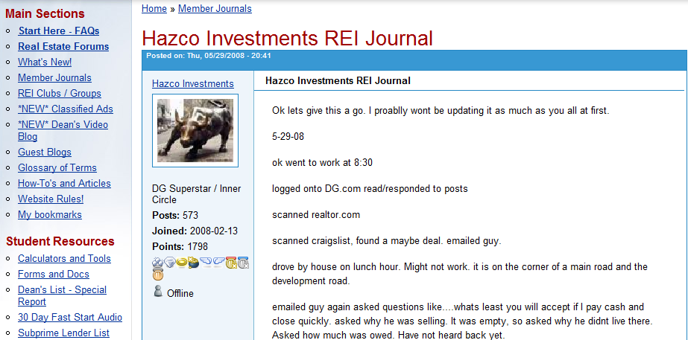

Bottom of a page within a post/thread.
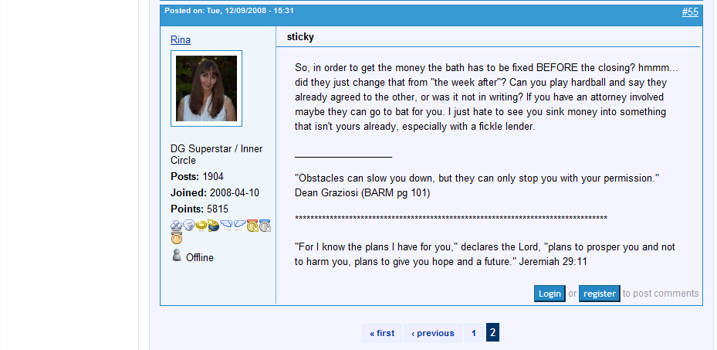
Can you please add this: to the TOP of the page within a post.

